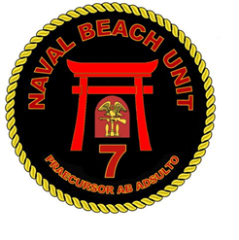
HAZMAT ISSUE CHIT
HOURS OF OPERATIONS
HAZMAT ISSUE: 0830 – 1030 & HAZMAT RETURN: 1330 - 1530
HAZWASTE DROP OFF (DOUBLE BAG, TAG, CALL 4520): 1330 - 1530
HAZMAT LOCATION:
LCU MAIN BASE
NAME:
DATE / TIME:
WORKCENTER:
LPO:
SPMIG/SPIN | NONMENCLATURE | NIIN 7 | QTY
ISSUING HAZMAT
MAINTENANCE REQUESTOR :
DIGITAL SIGNATURE: _____________________________
HAZMAT ISSUING PERSONNEL:
DIGITAL SIGNATURE: ______________________________
RETURNING HAZMAT
DATE RETURNED: | TIME RETURNED:
HAZMAT CUSTODIAN RETURN :
SIGNATURE________________________
NOTE:
* ALL requests shall be submitted at least 24HR in advance, and they are due at 1500 the day before.
* ALL hazardous materials must be turned in daily from 1330-1530.
* ALL HAZWASTE needs to be turned-in to S-3 for inspection prior to disposal.
DISTRO EMAIL: *** fs_nbu7_n43_s3@us.navy.mil / fs_nbu7_n41_s1@us.navy.mil ***


